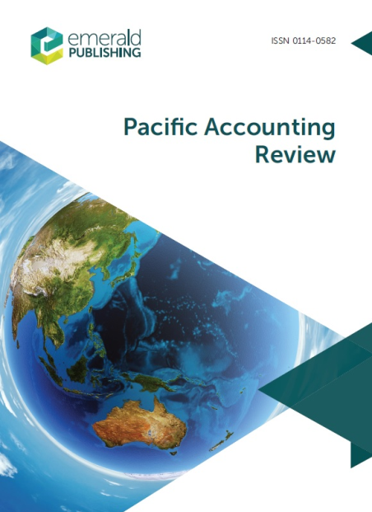
Call for Papers: Pacific Accounting Review

Special Issue: Contemporary Issues in Taxation and Accounting

A special issue of Pacific Accounting Review focusing on contemporary issues
in taxation and accounting will be published in mid-2019. Pacific Accounting Review, an international journal, publishes research into current developments in accounting and provides insight into how present practice is shaped and formed.

The special issue will explore the unique relationships between tax and accounting. We encourage submissions on major topics of interest including, but not limited to:

- The interaction of accounting and taxation in organisations
- Accounting for tax authorities versus accounting for shareholders: the rationale and effects of two sets of rules
- The impact of tax on entrepreneurship and entities
- Accounting and taxation in the Pacific region and in developing countries
- The role of accounting in transfer pricing and Base Erosion and Profit Shifting (BEPS) practices, reporting, and mitigation
- Cultural and international issues in accounting and tax
- Taxation and the evolution of financial reporting, and of the accounting profession
- Tax fraud, avoidance and accounting
- Interdisciplinary studies in accounting and taxation

Pacific Accounting Review offers a unique forum for research relating to, and research from, the Pacific region. However, this special issue also welcomes original research papers which focus on other geographic areas. Submissions may draw on an array of theoretical approaches – including empirical, qualitative, theoretical and historical – and a variety of contexts.

Submission procedures
- Interested authors are encouraged to submit their full papers for editorial consideration by the due date of 30 November 2018. Early submission is welcome. Full papers will be subject to PAR’s customary submission and external blind review procedures. All submissions must be original works that are not currently under review at other journals.
- Submission should be made via PAR’s submission system:
http://mc.manuscriptcentral.com/parev
- Please select “Contemporary Issues in Taxation and Accounting” from the drop down menu when submitting your manuscript.
- Authors are required to follow the submission guidelines.
- Full papers must be submitted by 30 November 2018

Guest editors for this special issue are:
Professor Lisa Marriott (Victoria University of Wellington – lisa.marriott@vuw.ac.nz)
Dr Julie Harrison (University of Auckland – j.harrison@auckland.ac.nz)
Dr Rob Vosslamber (University of Canterbury – rob.vosslamber@canterbury.ac.nz)
Dr Sue Yong (Auckland University of Technology – sue.yong@aut.ac.nz)

For further information, please contact
Dr Rob Vosslamber (University of Canterbury – rob.vosslamber@canterbury.ac.nz)
Please forward this Call for Papers to colleagues who may be interested.

